# 1.创建用户

create user BASICDEV identified by BASICDEV

drop user healerjean cascade 删除用户

# 2.授予连接数据库权限

Grant connect to BASICDEV

# 3.授予创建表的权限

Grant resource to BASICDEV

# 4.授予能够导入表的权限

Grant dba to BASICDEV

# 5.其他权限

Grant imp_full_database to bqft;

Grant exp_full_database to bqft;

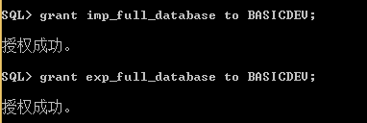

# 5导入dmp

**开始->运行->输入cmd->**

**IMP BASICDEV/BASICDEV@127.0.0.1:1521/orcl file=** **C:\Users\Administrator\Desktop\** **basic.dmp full=y**

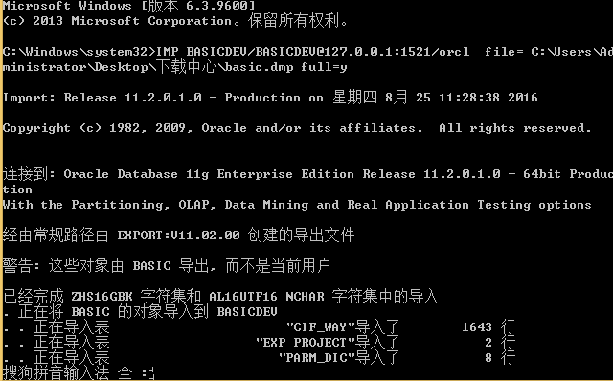

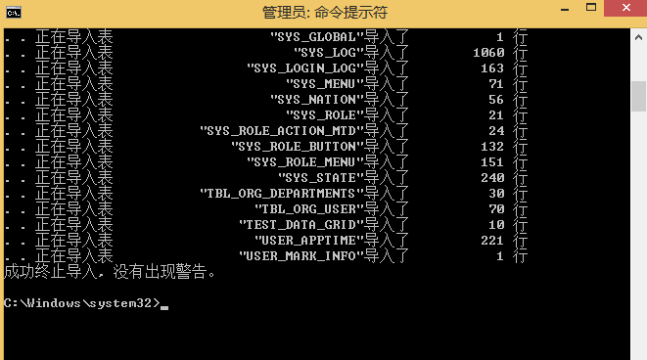

**IMP bqft/bqft@127.0.0.1:1521/orcl file=** **C:\Users\Administrator\Desktop\** **bqfttest20160906.dmp full=y**